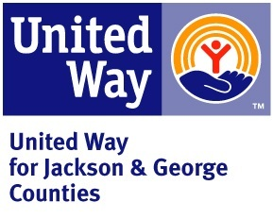
CLIENT SATISFACTION SURVEY
Please complete and put inside the drop box outside at 3510 Magnolia Street, Pascagoula, MS. Your response is anonymous.
- How satisfied are you with the overall service provided by this organization? Rating 0-10 (with 10 being very satisfied and 0 being not satisfied at all)
__________
- How easy is it to access the services we provide? Rating 0-10 (with 10 being very easy to access services and 0 being not easy to access services at all)
___________
- Do you feel that the staff treats you with dignity and respect? Rating yes or no; If no, please explain.
________________________________________________
________________________________________________
________________________________________________
- How well do our staff members perform their designated functions? Rating 0-10 (with 10 being staff performs very well and 0 being staff does not perform well at all)
____________
- Are there any additional comments you’d like to make?
________________________________________________________________
________________________________________________________________
________________________________________________________________
________________________________________________________________

